BEFORE BIRTH – DURING PREGNANCY

Medical tests:

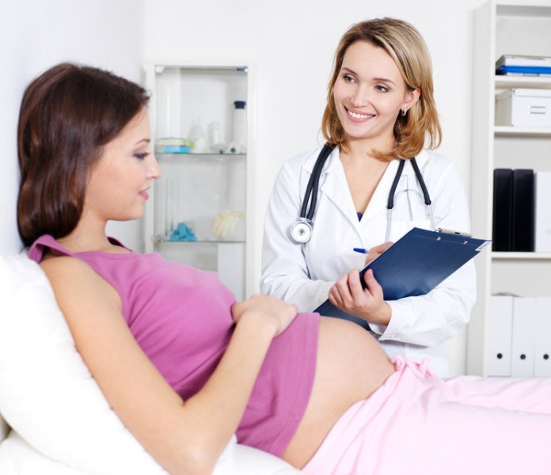

**First Trimester Prenatal Screening Tests**

This screening process can help to determine the risk of the fetus having certain birth defects. Screening tests may be used alone or in combination with other tests.

There are three parts of first trimester screening:

* **Ultrasound test for fetal nuchal translucency (NT).**Nuchal translucency screening uses an ultrasound test to examine the area at the back of the fetal neck for increased fluid or thickening and to determine pregnancy date.
* **Two maternal serum (blood) tests.**The blood tests measure two substances found in the blood of all pregnant women:
  + **Pregnancy-associated plasma protein screening (PAPP-A)**--a protein produced by the placenta in early pregnancy. Abnormal levels are associated with an increased risk for chromosome abnormality.
  + **Human chorionic gonadotropin (hCG)**--a hormone produced by the placenta in early pregnancy. Abnormal levels are associated with an increased risk for chromosome abnormality.

**Second Trimester Prenatal Screening Tests**

This Screening is usually performed by taking a sample of the mother's blood between the 15th and 20th weeks of pregnancy (16th to 18th is ideal). The multiple markers include:

**Alpha-fetoprotein screening (AFP).**This blood test measures the level of alpha-fetoprotein in the mothers' blood during pregnancy. AFP is a protein normally produced by the fetal liver and is present in the fluid surrounding the fetus (amniotic fluid), and crosses the placenta into the mother's blood. The AFP blood test is also called MSAFP (maternal serum AFP).

* Abnormal levels of AFP may signal the following:
  + Open neural tube defects (ONTD), such as spina bifida
  + Down syndrome
  + Other chromosomal abnormalities
  + Defects in the abdominal wall of the fetus
  + Twins--more than one fetus is making the protein

**What do each of the diagnostic tests tell the doctor**

|  |  |
| --- | --- |
| **Diagnostic test** | **Possible Findings** |
| Regular blood test | Confirmation of pregnancy (hCG hormone), blood group and Rh- disease, heamoglobin levels, platelet count |
| AIDS blood test | AIDS |
| Hepatitis B blood test | Hepatitis B |
| Rubella blood test | Rubella (German Measles) |
| Alphafeto-protein (AFP) blood test | Neural Tube Defects (NTD) |
| Urine Test | Confirmation of pregnancy (hCG hormone), sugar, albumin, bacteria |
| Sonogram (Ultrasound Scan) | Genetic deformities (including Down's syndrome) |
| Amniocentesis | Spina bifida (Open Spine), Anencephaly (Failure of brain formation), Down's syndrome |
| Chorionic Villi Sampling (CVS) | Tay-Sachs, sickle-cell anaemia, Down's syndrome, thalassaemia |

Food and Nutrients:

#### Foods You Should Eat

During pregnancy, the goal is to be eating nutritious foods most of the time.

To maximize prenatal nutrition, doctors advises emphasizing the following five food groups: fruits, vegetables, lean protein, whole grains and dairy products.

**Fruits and vegetables:  Lean protein:  Whole grains 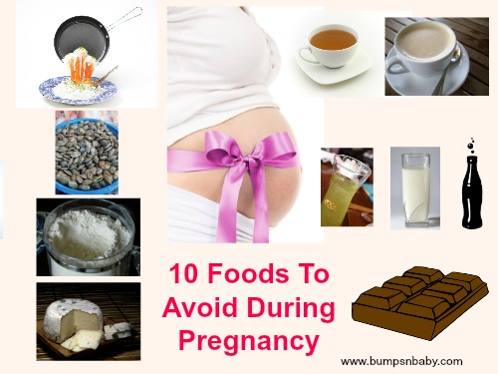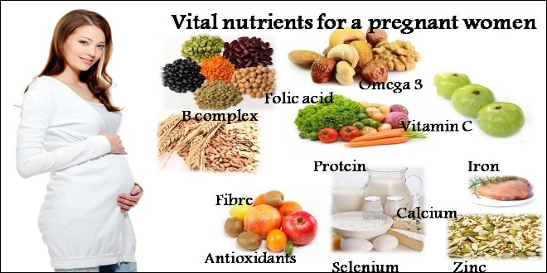Dairy**

**Folic acid**, also known as folate when found in foods, is a B vitamin that is crucial in helping to prevent birth defects in the baby's brain and spine.

Food sources: leafy green vegetables, fortified or enriched cereals, breads and pastas.

**Calcium** is a mineral used to build a baby's bones and teeth. If a pregnant woman does not consume enough calcium, the mineral will be drawn from the mother's stores in her bones and given to the baby to meet the extra demands of pregnancy.

Food sources: milk, yogurt, cheese, calcium-fortified juices and foods, sardines or salmon with bones, some leafy greens (kale, bok choy).

I**ron:** Pregnant women need 27 milligrams of iron a day, which is double the amount needed by women who are not expecting.

Food sources: meat, poultry, fish, dried beans and peas, iron-fortified cereal.

**Protein**: More protein is needed during pregnancy, but most women don't have problems getting enough of these foods in their diets.

Food sources: meat, poultry, fish, dried beans and peas, eggs, nuts, tofu.

**:**

#### Foods You Should AVOID

**Caffeine**

Taking in high doses of caffeine daily during pregnancy -- whether from coffee, tea, cola, cocoa, or energy drinks -- has long been associated with an increased risk of [miscarriage](http://www.parents.com/pregnancy/complications/miscarriage/)

**Soft cheeses**

It's best to avoid cheeses such as Brie, goat, Camembert, feta, queso blanco, and blue or other veined varieties. Why? They may be unpasteurized and contaminated with listeria -- bacteria that can trigger food poisoning.

**Fish**

You probably already know that mercury, which is present in many fish, is dangerous for your baby.

**Eggs**

No one is going to tell you to avoid eggs, which are a high-quality source of protein and contain important nutrients like choline. But eggs do have some risk of being contaminated with salmonella, which is more dangerous for pregnant women than for the general population.

**ALCHOHOL :**

[Absolutely not, warn many experts](http://www.parents.com/pregnancy/everything-pregnancy/no-birth-control-no-alcohol-says-cdc/). Heavy drinking can lead to [Fetal Alcohol Syndrome](http://www.parents.com/pregnancy/complications/fetal-alcohol-syndrome/) (FAS), which causes mental retardation and a host of abnormalities.

**Meat**

**Sushi:**

**Unpasteurized Juice:**

Physical and Emotional Changes :

**The Physical Changes During Pregnancy**

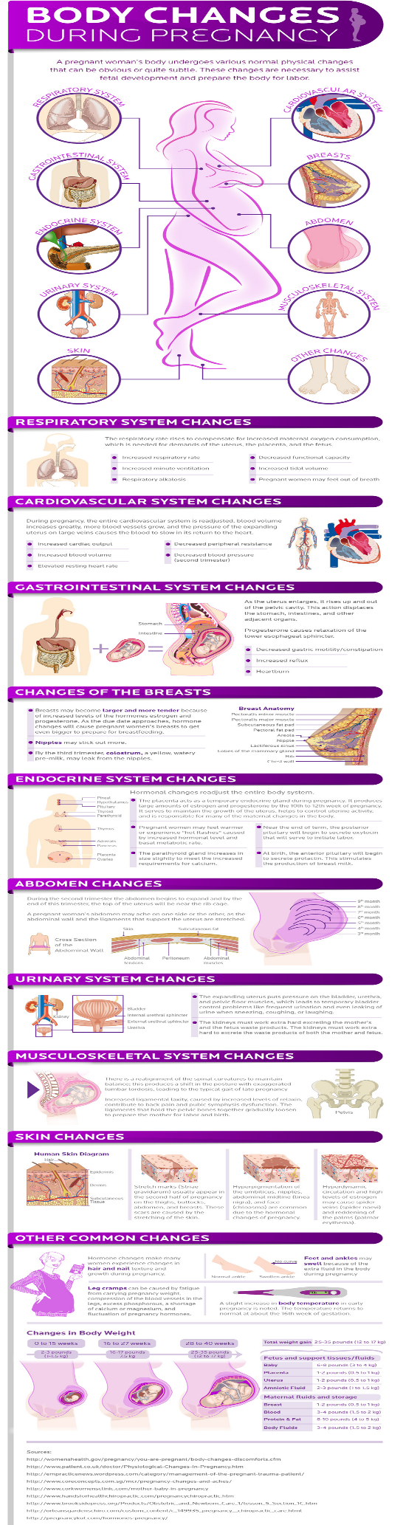

OR( incase the image is not possible to display into the PHYSICAL CHAGES OPTION , then display the following text )

### Nasuea

"Morning sickness," as it is typically referred to, is present usually from 6 to 14 weeks, but may last the majority of the pregnancy. Some women do not experience morning sickness while others are hospitalized for periodic worsening that prevents proper hydration and/or nutrition.

### Sore and growing breasts

Early in your pregnancy, your breasts may be tender and swollen. After the first few months, your areolas — the pigmented circles around your nipples — will also be bigger and darker. Later in the pregnancy as your breasts prepare for breastfeeding, they get even bigger and may leak an early form of milk called colostrum. Be sure to wear a well-fitting bra that provides both comfort and support.

### Fatigue and body aches

Fatigue is very common in the first four months of pregnancy. This is mostly due to the hormone effects of early pregnancy, but increased fatigue and decreased exercise tolerance is common throughout pregnancy.

**Growing abdomen**

The most apparent physical change will be your growing mid-section. For most women, this growth is noticed from the fourth month through the end of pregnancy.

**Stretch marks and skin changes**

Stretch marks—they’re one of the most talked about changes during pregnancy, and also one of the most common. They appear in 50 to 90 percent of all pregnant women, usually showing up in the latter half of pregnancy

**Weight gain**

Normal weight gain ranges from 25 to 35 pounds. Most weight gain happens between 10 to 40 weeks with approximately 8 pounds per 10 weeks. During the first 10 weeks, some may have a small drop in weight or if nausea and/or vomiting issues are steady, but most women gain 3 pounds or less in the first 10 weeks.  
  
During pregnancy, you should only consume 300 more calories per day than the normal dietary needs.

**Digestive and urinary issues**

The digestive system slows down the movement of fluids and solids through the body during pregnancy and increased uterine size increases pressure on intestinal tract. Both processes increase the risk for nausea, vomiting, constipation and haemorrhoids

Urination may become increasingly frequent due to enlargement of the uterus and pressure placed on the bladder. During pregnancy there is an increased risk for urinary tract infections, but common symptoms of UTI, such as painful urination, may be reduced due to hormonal changes in urinary tract.

**The Emotional Changes During Pregnancy**

During pregnancy it is normal to be preoccupied with how your body is quickly changing, how to manage symptoms, how different your life is becoming, worry about the pregnancy going well, finances, and keeping up with everyday life.

It is common to go through many of the following changes in a pregnancy:

* **First** **trimester**. Extreme fatigue or morning sickness can color your daily life. Moodiness (as with premenstrual syndrome) is normal. Happiness and anxiety about a new pregnancy, or feeling upset about an unplanned pregnancy, are also common.
* **Second** **trimester**. Fatigue, morning sickness, and moodiness usually improve or go away. You may feel more forgetful and disorganized than before. Looking heavier than normal, then looking visibly pregnant and feeling the baby move, can make you feel any number of emotions.
* **Third** **trimester**. Forgetfulness may continue. As your due date nears, it is common to feel more anxious about the childbirth and how a new baby will change your life. As you feel more tired and uncomfortable, you may be more irritable than before.

For some women, serious anxiety or depression problems improve during pregnancy. For others, they do not. If you find no pleasure in daily life, or suffer from a lot of sleeplessness (insomnia), sadness, tearfulness, anxiety, hopelessness, feelings of worthlessness and guilt, irritability, appetite change, or poor concentration, talk to your health professional. Without treatment, mental health problems can get in the way of a healthy pregnancy.

Exercise:

## **What Not to Do While Pregnant**

* Hot or Bikram yoga
* Major backbends
* Lower spinal or deep twists
* Too much ab work
* Belly down postures (Cobra, Locust, Bow, etc.)
* Lying on your back for a long time
* Overstretch – Your body, clever little thing it is, is producing a hormone that softens tissues and ligaments in the pelvic floor (trust me you’ll be grateful for this when b-day rolls around!), which increases your risk of pulling a muscle if you stretch further than usual.
* Breath retention (kumbhaka)

## **What to Do While Pregnant**

* Get the all-clear from your doc or midwife
* Be present in your body and with your baby
* Be gentle and kind to yourself
* Listen to, and love, your body
* Check all judgment at the door

Here are eight yoga poses to ease pregnancy pains whilst expecting.

1. Reclined Bound Angle Pose (Supta Baddha Konasana)

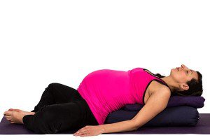

This pose increases blood circulation in the lower abdomen, stretches the groin, and increases external rotation in the hips. It’s also my favourite way to calm down and relax my anxious mind.

Make sure to modify this posture for pregnancy by placing a bolster or two under your back and head to create an incline (so you are not flat on your back), and a block between feet to broaden your pelvis.

2. Child’s Pose (Balasana)



Balasana can fight off nausea, relieve anxiety, and quiet the mind. Modify for pregnancy by placing a bolster under the torso for support.

3. Cat/Cow Pose (Marjaryasana Bitilasana)

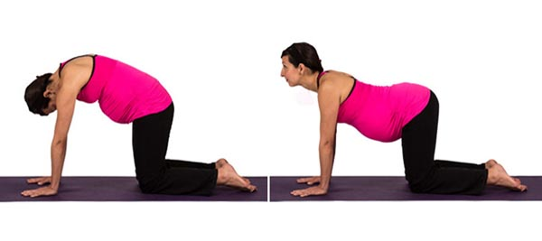

As the baby grows, more pressure is put on the spine, so moving on hands and knees relieves that pressure. Table Top position also encourages the baby into proper position for delivery and can provide relief during contractions in labour.

4. Garland or Squat Pose (Malasana)



Hanging out in a squat like this really opens the hips and pelvis, which is ideal for prenatal practice. It is also known to stimulate digestion and is a great stretch through the legs and back. Modify for pregnancy by leaning against a wall or squatting on blankets. Only suitable until about 30 weeks.

5. Goddess Pose (Utkata Konasana)



This is an amazing prep pose for childbirth. It opens the hips and groin and creates space in the pelvis. It also strengthens and tones the many muscles in the legs. We often have a tendency to internally collapse the knee, so line it up with your second toe to prevent injury.

6. Extended Triangle Pose (Trikonasana)

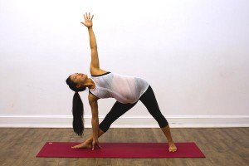

I found Trikonasana incredibly helpful for relieving backache and creating length through the side body. It is also known for its ability to reduce stiffness in the neck, tone the pelvic floor, and relieve indigestion. Take a shorter stance than usual and microbend the front knee.

7. Extended Side Angle Pose (Utthita Parsvakonasana)

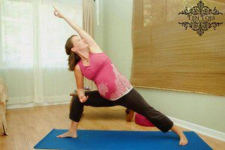

Another lovely side body stretch to create space for the baby, Extended Side Angle is also a wonderful prep pose for childbirth as it strengthens the quads and increases stamina.

Modify your typical expression by resting your front elbow on your front knee rather than reaching for the floor. This will help stabilize your body as bub grows and throws off your center of gravity.

8. Corpse Pose (Savasana)



When you melt into Savasana, do so on your side, with a bolster placed between your legs as lying flat on your back is not recommended.

Video Link for various yoga poses: https://www.youtube.com/watch?v=B87FpWtkIKA